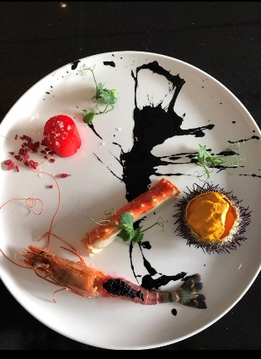

**Mosaico del Mare**

***Beetroot Poached Queen Scallop, Gallipoli Red Prawn with Sevruga Caviar, King Crab, Sea Urchin Gelato, Ink Dressing***

**For Sea Urchin Ice Cream**

180 g premium sea urchin meat

400 g heavy cream

180 g Greek yogurt

360 g milk

20 g sugar

200 g egg yolk

5 g glucose

1 g salt

1g fresh vanilla seeds

**Method**

Cream the yolks and sugar in a blender while bringing cream and milk to 71°C. Whisk in the glucose into the dairy. Blend on a medium spin, very slowly add the hot milk cream combination tempering the custard as it spins. Add the sea urchin meat, the yogurt and vanilla and blend on medium high add the salt, strain, chill, and churn.

**For the Queen Scallop**

200 g fresh Queen scallop

200 g fresh red beetroot

50 g Pinot grigio wine

20 g apple vinegar

2 g sage

2 g rosemary

2 gr thyme

2gr lemon skin

500gr water

1 garlic clove

Salt and pepper to taste

**Method**

Slice thinly 50 g of the beetroot and let it air dry for 45 min in a hot box or dryer.

Once the beetroot chips become dry, chope it in small pieces, to give texture to the scallop into the plate.

Blend into a juicer machine the remaining 150g of beetroot.

In a pot add the beetroot juice and all other ingredients with water and bring to boil.

Poach the whole scallop for 2 minutes, remove from the stock and let it rest.

**For the red prawn**

80 g red Gallipoli prawns

5 g sevruga caviar

5gr extra virgin olive oil

2g orange juice

2 g fresh dill

Salt and pepper to taste

**Method**

Clean and wash the prawns.

Marinate with olive oil, orange juice and dill for 20 minutes.

Serve with caviar.

**For the Crab**

200 g Alaska king Crab

50 g Pinot grigio wine

20 g red wine vinegar

20 g fennel

20 g celery

20 g onion

500 g water

Salt and pepper to taste

**Method**

Prepare a broth with all ingredient except the crab.

Boil the broth for 20 minutes.

Poached the crab into the broth, for 4 minutes.

Chill and serve.

**For the Ink dressing**

20 g fresh squid ink

100 g extra virgin olive oil

20 gr aged Modena balsamic vinegar

Salt and pepper to taste

**Method**

Put all ingredients in a pot on slow fire.

Let it slow stew for 15 minutes.

Strain the liquid and chill.

Use as condiment for the sea food.